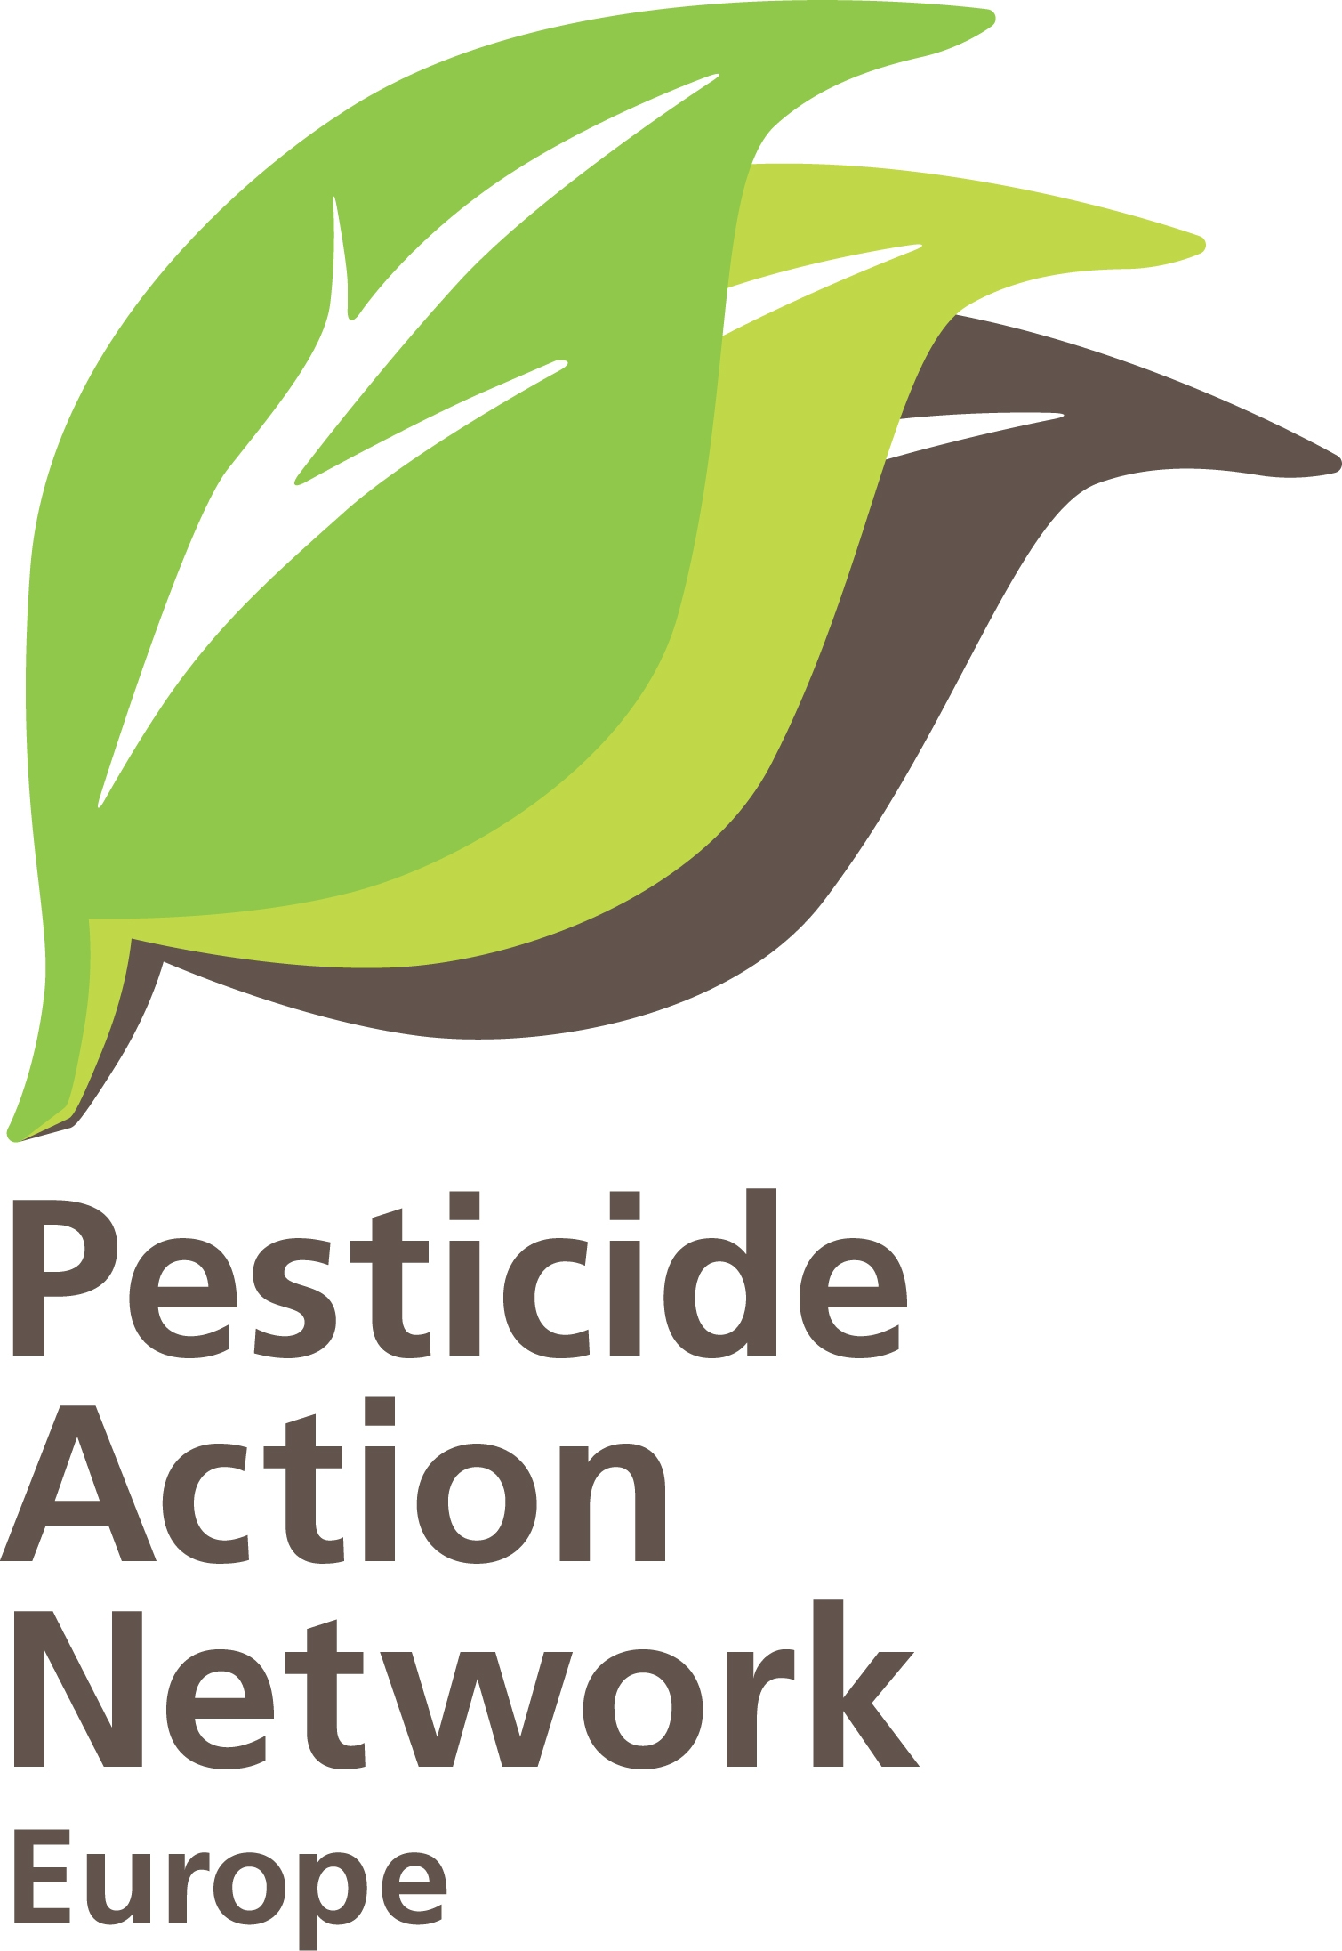 | Pesticide Regulation 1107/2009 entering in force  Brussels, 14-06-2011  PAN Europe  Contact: Hans Muilerman, hans@pan-europe.info,  tel. 00316-55807255.

To:
Mr. John Dalli
European Commissioner for Health and Consumer Policy
European Commission
B-1049 Brussels.

Concerning:
Pesticide Regulation 1107/2009 entering in force.

Dear Commissioner, dear Mr. Dalli,
Today, the new pesticide Regulation 1007/2009 enters in force. This marks the beginning of the new revolutionary system in which ‘cut-off’ criteria will be used in pesticide authorisation for the very first time. We hope a new era of science-based pesticide evaluation will begin and we would like to encourage you to clearly mark this moment by instructing those civil servants doing the evaluation of pesticides on the changes needed.

For pesticides, up to now, the EU has used traditional risk assessment and it was very hard, or even impossible, to ban a pesticide based on these methodologies if industry resisted fiercely. Gradually through the years we have seen the evaluation system move away from science and seen the introduction of numerous ways of theoretical calculations and questionable assumptions (‘higher tier’ risk assessment) all leading to a more favourable outcome for the applicants/substances. A few examples are,
- No-effects levels are set without any actual data, based on extrapolation from unrealistic high dose toxicity studies (also assuming only a linear dose-response relation is possible), for example the TTC; (Threshold of Toxicological Concern) which assumes (no test) a safe dose even when there is cause to believe a single mutation to a gene can propagate into a disease;
- Cancers shown in animal studies were increasingly qualified ‘irrelevant’ for humans (often mice); many other adverse health effects observed in animal studies qualified as ‘non-treatment related’, mostly based on the opinion of the applicant;
- No testing of the very vulnerable phase of life, the developmental phase (not in tests on cancers, rarely in neurotoxic tests and not in endocrine tests);
- Data from independent scientists are not taken into account merely because exposure routes or doses deviated from standard OECD tests; thus the only data used in estimating a safe exposure level comes from the party with a tremendous financial interest to find that the pesticide is indeed safe enough to use;
- Non-scientific approach of single substance evaluation (disregarding combination effects);
- Even long-term toxicity and carcinogenity studies can be waived in the data requirements;
- Use of ‘historical control data’ in stead of enough control animals in studies opens many ways of claiming adverse effects are within ‘control range’;
- Assessments for wildlife to allow abandoning safety factors (like microcosms) and even damage (LC10) resulting in vulnerable species being unprotected;
- “Innovations” in risk assessments allowing biodiversity to be completely killed (like non-target arthropods) on the condition organisms return from elsewhere (‘recovery’), one year later;
- Metabolites of unknown danger can be classified “non-relevant’ and excluded from assessment;
- Mitigation measures developed in the risk assessment arena, which will most likely not be enforced in practice (protecting bees by instructions on the label, large buffer zones, spraydrift reduction, etc.), but nonetheless allow pesticides to enter the market.

The traditional risk assessment system moved away from protecting people and the environment and became more and more a tool in the hands of those supporting commercial interest. Needless to say that industry and industry lobby clubs like ILSI and EXPONENT pushed from the beginning for these approaches, organised “scientific consensus meetings” with regulators and were happy to develop and propose the many theoretical calculations and assumptions. ILSI-representatives in EFSA introduced the same elements there. The voting system in the Standing Committee (representatives of the Ministry of Agriculture) also contributed to the problem of moving away from science and forced civil servants in many cases to write down ‘white’ what is clearly ‘black’. This all is in great contradiction to Directive 91/414, stating protection of human and the environment will prevail over commercial interests.

Our observation of a not properly functioning risk assessment system is supported by studies on biodiversity. Recent research of 12 European institutes (Geiger, 2010) show that adverse effects of pesticides on biodiversity are still not controlled and remain one of the main causes of loss of biodiversity: “We conclude that despite decades of European policy to ban harmful pesticides, the negative effects of pesticides on wild plant and animal species persist, at the same time reducing the opportunities for biological pest control”.
This means a full transition to other assessment methods needs to be made from 14 June on and traditional risk assessment and its ways of corrupting science abandoned. We think you as the Health Commissioner have to play a major role in convincing people and realising the paradigm change needed.

It will certainly not be easy to change traditions if this was practice for decades and regulators might have got the impression in the end this is the normal way of evaluating chemicals. Already now there are several signs the transition will not be easy and even EU institutes seem to resist to the changes adopted by Parliament and Council:
- EFSA tried to dismantle the new obligation in the Regulation to use independent science by qualifying industry sponsored studies as of highest reliability and relevance and independent studies of questionable use:
http://www.pan-europe.info/News/PR/110301.html
- Germany/UK proposed to reverse the ‘cut-off’ regime for endocrine disrupting pesticides in the new Regulation back into traditional risk assessment with its numerous ways of by-passing a ban for pesticides:
http://www.pan-europe.info/News/PR/110525.html
- On the basis of Comitology -just a few days before the new Regulation entered in force- the dangerous fungicide Carbendazim, capable of causing malformations in the foetus, was granted market access while it would not be allowed under the new Regulation:
http://www.pan-europe.info/Campaigns/chemicals/spotlight.html
http://eur-lex.europa.eu/LexUriServ/LexUriServ.do?uri=OJ:L:2011:122:0071:0075:EN:PDF
- Member States massively and growingly choose for derogations, by-passing the Regulation, to allow illegal pesticides on the market without solid safety measures for people and the environment and disregarding procedures:
http://www.pan-europe.info/News/PR/110126.html

The fact DG SANCO in 2007 decided to create a second chance (even with commercial advantages) for applicants of already banned pesticides absorbed all capacity from staff for several years and left no time to work on developing new methodologies and modernised guidelines for the Regulation. It even lead to a postponement of the assessment of pesticides under the new Regulation. We see this choice as a grave mistake. We think extra capacity is needed to work on the ‘cut-off’ regime and new methodologies.

We hope you will support a real change and not allow traditional risk assessment methods to be continued. Especially the uniform principles for authorisation, developed under heavy industry influence, should be revised without delay. We propose you launch immediately a taskforce of independent actively publishing scientists to develop new, modern science-based data requirements, develop evaluation methods based on the hazard approach (not risk), and create an important place for independent scientists in decision-taking. EFSA may-be could have an important role in pesticide safety in time, but given their love of traditional risk assessment, they themselves need to go in transition first.

We hope for your reaction on our proposal,
Sincerely yours,

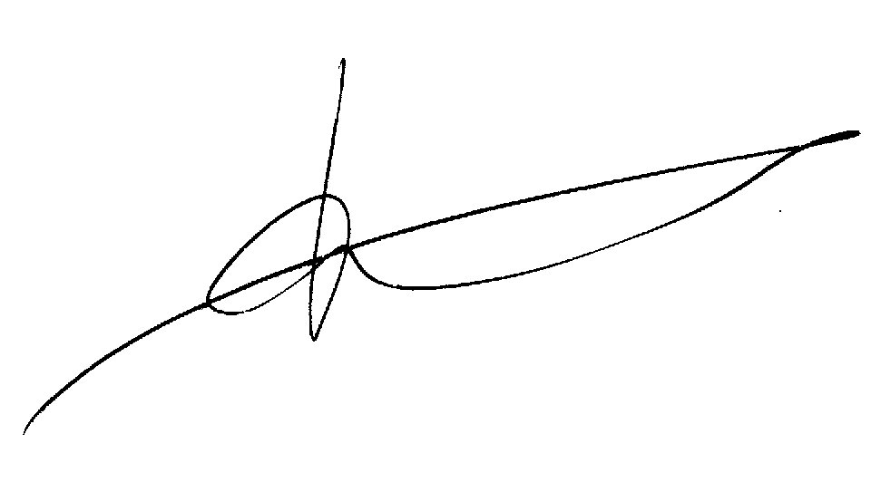

Hans Muilerman.
Pesticide Action Network Europe.

http://www.ucc.ie/staff/memmers/pdfs/Geiger.etal.Basic.Applied.Ecol.2010.pdf Conclusion: “Of the 13 components of intensification we measured, use of insecticides and fungicides had consistent negative effects on biodiversity”.

